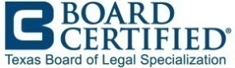
The Texas Board of Legal Specialization is now accepting online board certification applications for 2024. You can find the specific requirements for each of the 27 specialty areas in the “Apply” section of www.tbls.org.

Certification applications must be submitted by April 8, 2024; the exam is on September 30 and October 1, 2024, in Austin. If you have questions about the TBLS Board Certification program, please contact TBLS at 1-833-413-0253 or send an e-mail to tbls@tbls.org.

